**Experiment 1: Create a Static Home Page by using HTML Tags**

**Aim:** The aim is to create a static home page (Resume) using HTML

**Tags Used:**

<div>

<h3>

<ul>

<li>

<table>

<td>

<tr>

<span>

**Implementation:**

**Output**

**<https://manu00147.github.io/RA1711003011284/>**

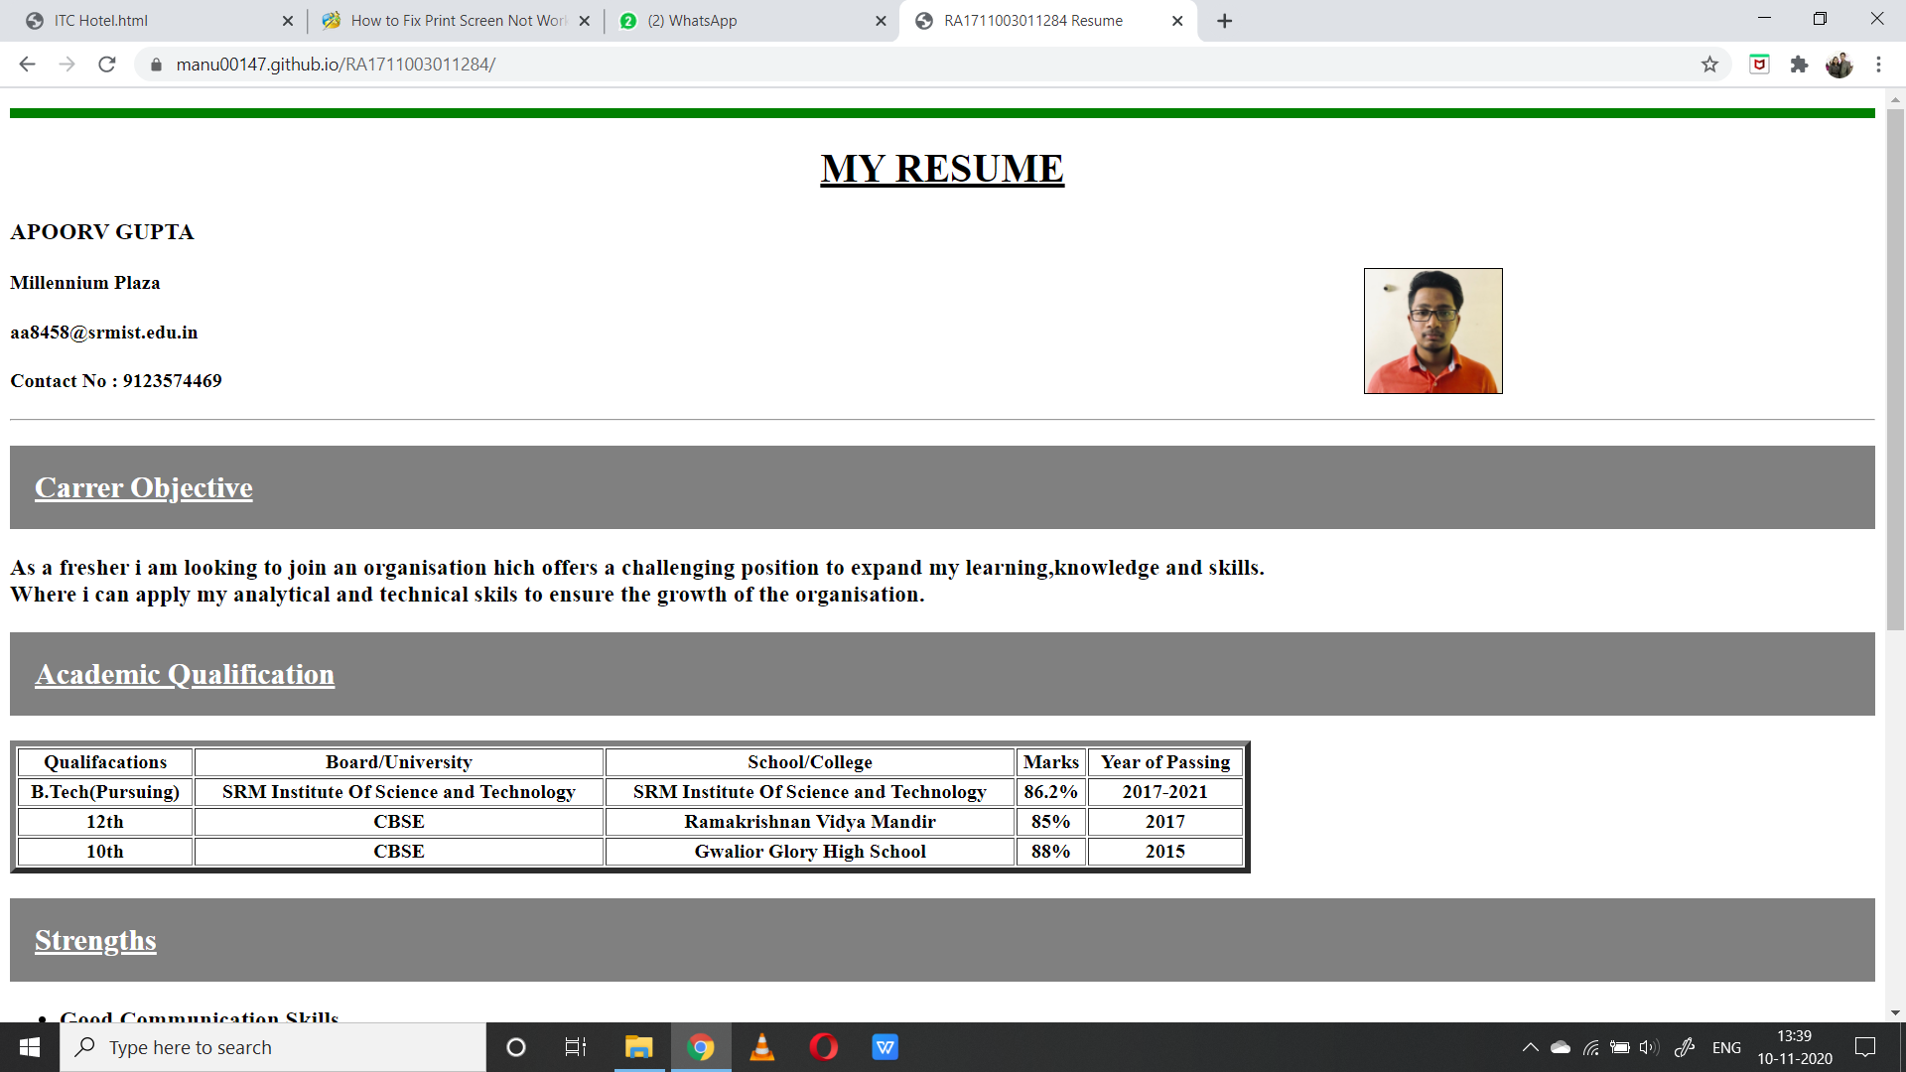

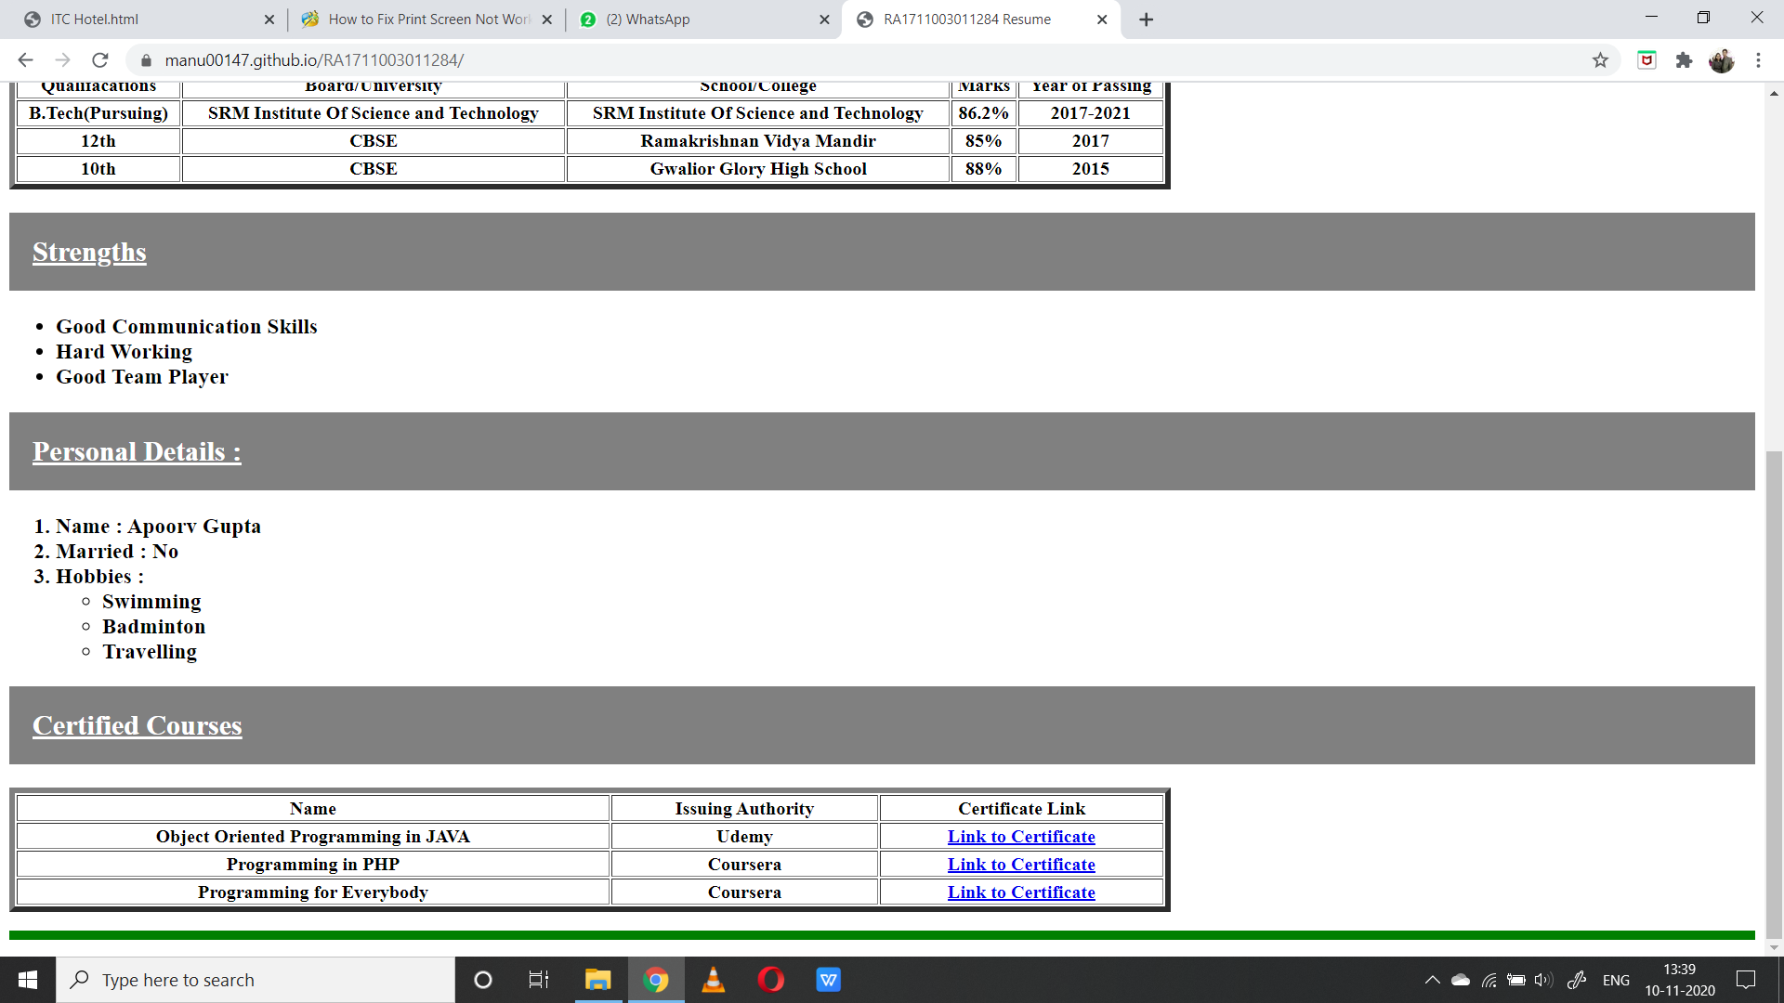

|  |
| --- |
| <!DOCTYPE HTML> |
|  | <HTML> |
|  | <HEAD> |
|  | <TITLE>RA1711003011284 Resume</TITLE> |
|  | </HEAD> |
|  | <style> |
|  | p{ |
|  | border:4px solid green |
|  | } |
|  | </style> |
|  | <p> |
|  | <body> |
|  | <center> |
|  | <u> |
|  | <h1>MY RESUME</h1> |
|  | </u> |
|  | </center> |
|  | <h3>APOORV GUPTA</h3> |
|  | <img src = "resumepic.jpg" border = "1" width = 110 height = 100 hspace = 300 align = right> |
|  | <h4>Millennium Plaza</h4> |
|  | <h4>aa8458@srmist.edu.in</h4> |
|  | <h4>Contact No : 9123574469</h4><hr> |
|  | <h2> |
|  | <u> |
|  | <div style = "background-color:grey;color:white;padding:20px"> |
|  | Carrer Objective |
|  | </u> |
|  | </h2> |
|  | <h3> |
|  | As a fresher i am looking to join an organisation hich offers a challenging position to expand my learning,knowledge and skills.<br> |
|  | Where i can apply my analytical and technical skils to ensure the growth of the organisation. |
|  | </h3> |
|  | <h2> |
|  | <div style = "background-color:grey;color:white;padding:20px"> |
|  | <u>Academic Qualification</u> |
|  | </h2> |
|  | <table border = 5 width = 1000> |
|  | <tr> |
|  | <th>Qualifacations</th> |
|  | <th>Board/University</th> |
|  | <th>School/College</th> |
|  | <th>Marks</th> |
|  | <th>Year of Passing</th> |
|  | </tr> |
|  | <tr> |
|  | <th>B.Tech(Pursuing)</th> |
|  | <th>SRM Institute Of Science and Technology</th> |
|  | <th>SRM Institute Of Science and Technology</th> |
|  | <th>86.2%</th> |
|  | <th>2017-2021</th> |
|  | </tr> |
|  | <tr> |
|  | <th>12th</th> |
|  | <th>CBSE</th> |
|  | <th>Ramakrishnan Vidya Mandir</th> |
|  | <th>85%</th> |
|  | <th>2017</th> |
|  | </tr> |
|  | <tr> |
|  | <th>10th</th> |
|  | <th>CBSE</th> |
|  | <th>Gwalior Glory High School</th> |
|  | <th>88%</th> |
|  | <th>2015</th> |
|  | </tr> |
|  | </table> |
|  | <h2> |
|  | <div style = "background-color:grey;color:white;padding:20px"> |
|  | <u>Strengths</u> |
|  | </h2> |
|  | <ul> |
|  | <b> |
|  | <h3> |
|  | <li>Good Communication Skills |
|  | <li>Hard Working |
|  | <li>Good Team Player |
|  | </h3> |
|  | </b> |
|  | </ul> |
|  | <h2> |
|  | <div style = "background-color:grey;color:white;padding:20px"> |
|  | <u>Personal Details :</u> |
|  | </h2> |
|  | <ol> |
|  | <b> |
|  | <h3> |
|  | <li>Name : Apoorv Gupta |
|  | <li>Married : No |
|  | <li>Hobbies :</li> |
|  | <ul> |
|  | <li>Swimming |
|  | <li>Badminton |
|  | <li>Travelling |
|  | </ul> |
|  | </ol> |
|  | <h2> |
|  | <div style = "background-color:grey;color:white;padding:20px"> |
|  | <u> |
|  | Certified Courses |
|  | </u> |
|  | </h2> |
|  | <table border = 5 width = 1000> |
|  | <tr> |
|  | <th>Name |
|  | <th>Issuing Authority |
|  | <th>Certificate Link |
|  | </tr> |
|  | <tr> |
|  | <th>Object Oriented Programming in JAVA |
|  | <th>Udemy |
|  | <th><a href = "https://udemy-certificate.s3.amazonaws.com/image/UC-8c58b1b7-e41c-4467-91ae-876a398f3739.jpg">Link to Certificate</a> |
|  | </tr> |
|  | <tr> |
|  | <th>Programming in PHP |
|  | <th>Coursera |
|  | <th><a href = "coursera.org/verify/5AJAAMQWHCEY">Link to Certificate</a> |
|  | </tr> |
|  | <tr> |
|  | <th>Programming for Everybody |
|  | <th>Coursera |
|  | <th><a href = "coursera.org/verify/WCQLSKCC34KV">Link to Certificate</a> |
|  | </tr> |
|  | </table> |
|  | </body> |
|  | </p> |
|  | </html> |

**Result:**The experiment was successfully completed.